Introduction:

Macromedia Flash is a program that creates interactive and animated media such as motion graphics, videos, presentations, and websites. We can understand animation as bringing a picture to life. An animation covers all changes that have a visual effect. A computer-based animation is an animation performed by a computer using graphical tools to provide visual effects.

Objectives:

- To animate something like picture or objects and bring it to life i.e. bouncing ball, walking man, flying bird, etc.
- To understand different uses of different tools for different purposes.
- To be able to Script in animation.
- To be familiar with flash and action script.

Materials:

Software used: Macromedia Flash Professional 8.

Steps:

- Open macromedia flash, and new file using flash document.
- Use ‘Oval tool’ to create a ball by clicking ‘Shift’ and mouse on the start of the frame.
- Choose the color of your desire from ‘color section’ and fill the ball using ‘paint bucket tool’.
- Go to frame 40 on ‘timeline’ and insert the key frame by pressing f6.
- Now, Drage the ball in the end of the frame.
- Go to frame 20 on ‘timeline’, right click and choose motion tween.
- Now move that ball little higher on frame 20 only to create bouncing effect during animation.
- Create a new layer in the ‘timeline’ using the ‘insert layer’ located in left bottom in ‘timeline section’.
- Create two boxes using the ‘Rectangle tool.’
- Convert the boxes to symbol by right click and choose ‘convert to symbol’ and choose button on type.
- Use ‘Text tool’ to add ‘START’ & ‘STOP’ text over the buttons.
- Then right click on the symbol buttons then choose ‘action’ to write script in each of them.
    - For Start Button write this action script in ‘action section’ then click on the ‘Check Syntax’ just above the writing section:
on(release){
play();
}
    - For Stop Button write this action script in ‘action section’ then click on the ‘Check Syntax’ just above the writing section:
on(release){
stop();
}

- Enter ‘Ctrl + Enter’ key to play the animation and user can control animation using ‘START’ & ‘STOP’ buttons.
- Save the file.

Shortcut Keys:
- Ctrl + enter = To run animation.
- Ctrl + N = New File.
- Alt + W = Close.
- Ctrl + Z = Undo.
- Ctrl + O = Duplicate.
- F6 = To insert Keyframe.
Windows in Macromedia Freehand MX.
- Properties: Contains the details of the document like size, background, framerates with access to edit them.
- Filters: Allow users to apply various filter effects to selected objects or text in their vector graphics.
- Parameters: Allow users to modify and fine tune the properties and attributes of selected objects or text within their vector graphics.
- Actions: Allows users to add interactivity to design elements. It allows for actions like hyperlinks, navigation, and multimedia control, enhancing the usability of designs for web and multimedia projects.
- Timeline: For managing frames.
- Tools: Contains many tools we can use for different purposes.
- Align: Allows users to precisely position and align selected objects within their design.
- Info: Provides detailed information about selected objects including their coordinates, dimensions, rotation angles and other properties.
- Transform: Allow users to perform transformations on selected objects, such as scaling, rotating, skewing, and shearing.
- Library: Allow users to store, organize and retrieve reusable design elements such as graphics, symbols, and templates.

Tools Used:
- Selection tool: To select object.
- Oval tool: To create circles and ovals.
- Rectangle tool: To create shapes like rectangle for Button.
- Text tool: To write any text.
- Fill tool: To fill colors.
- Frame: To add keyframes.
- Motion Tween: To create a motion from first frame to last.

Discussion and Analysis:
To create any animation and seem to bring them to life, macromedia flash is a great application to do so. It can also come handy for complex animations. It might be difficult to understand the use of different tools and create perfect, required animations but with a bit of patience and practice, it is easy to use. In this, with the help of action scripts we can control animations.

References:
- YouTube.
- Google.
- ChatGPT.
- Provided Notes

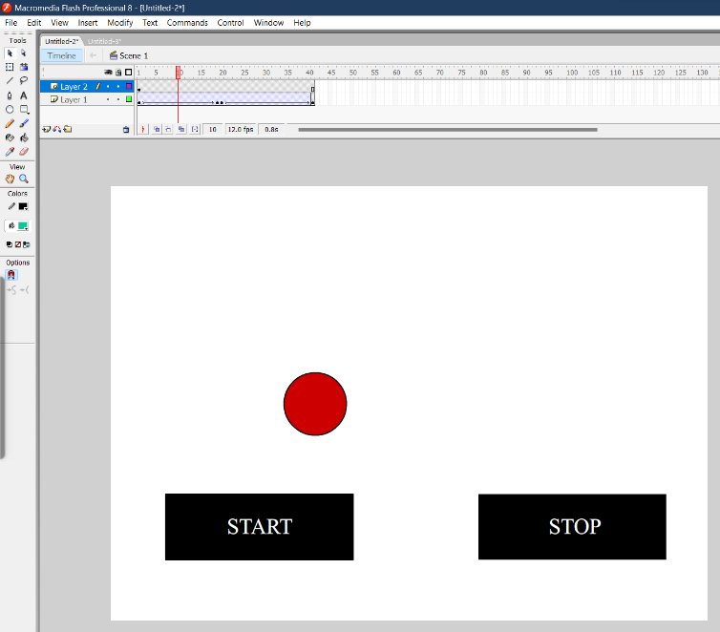
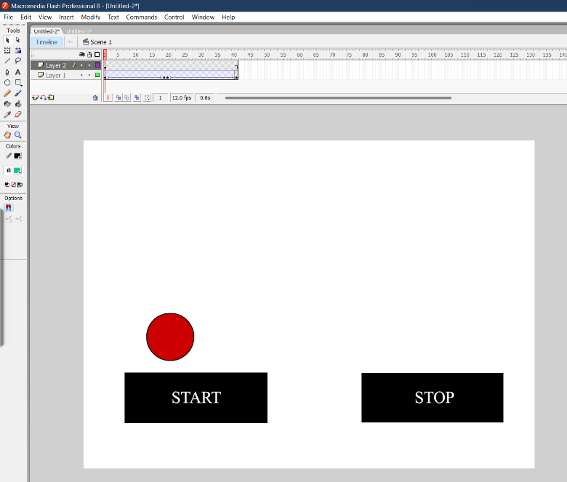
Action Scripts to start and stop animations in Macromedia Freehand MX.


